# Conceptos

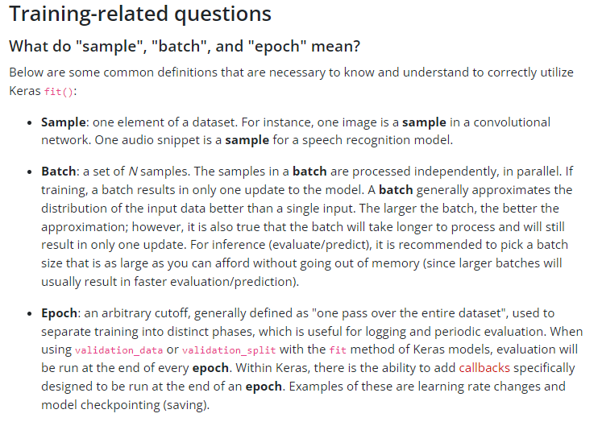

<https://keras.io/getting_started/faq/#what-do-sample-batch-and-epoch-mean>

“An epoch is an iteration over the entire x and y data provided…“

<https://keras.io/api/models/model_training_apis/>

## Trials

Un trial tiene x cantidad de epochs, donde en cada trial cambia algunos o todos los valores de hyperparametros.

 Evaluates a set of hyperparameter values. This method is called multiple times during search to build and evaluate the models with different hyperparameters and return the objective value.

<https://keras.io/api/keras_tuner/tuners/base_tuner/#:~:text=run_trial%20method-,Tuner.,and%20return%20the%20objective%20value>.

## Cantidad de trials

Cada trial tiene 100 epochs se corrieron 50 trials

De las cuales ya que por cada epoch se tiene un score por cada trial solo se guarda la epoch con mejor rendimiento/score

Dudas:

Todos los modelos con todos los resultados deben de guardarse?, es decir, no me refiero a los resultados, sino el archivo del modelo, ya que por cada trial me genera un modelo del mejor resultado, es decir si tiene 100 epoch en cada trial me guarda solo el mejor de los 100,

y si tenemos 50 trials tenemos 50 mejores modelos, dado que a mí solo me interesa el mejor se podían borrar los otros 49 que no son?

Ya los borre porque se me llenó la memoria del google drive.

Solo guarde el mejor.

## Búsquedas en google scholar

random search time series lstm

random search time series

hyperband time series

hyperband lstm

random search time series lstm

bayesian optimization time series

bayesian optimization time series hyperparameter

02-09

Segun “An Optimally Configured HP-GRU Model Using Hyperband for The Control of Wall Following Robot 2021”

Algoritmo: Hyperband

Total Trials =10

Execution/trial=5

Segun “Optimally configured Gated Recurrent Unit using Hyperband for the long-term forecasting of photovoltaic plant” 2021

Algoritmo: Hyperband

Total Trials =10

Execution/trial=????

Segun LSTM: A Search Space Odyssey October 2017

We performed 27 random searches (one for each combination of the nine variants and three data sets). Each random search encompasses 200 trials for a total of 5400 trials of randomly sampling

Algoritmo: random search

Total Trials =200

Execution/trial=????

Segun <https://link.springer.com/article/10.1007/s10489-021-02924-z#Tab4>

Epoch was set to 200 and the models were trained before and after optimization

Compared with the unoptimized model, the convergence speed of the optimized model improved by about 20 epochs, indicating the effectiveness of the Bayesian optimization algorithm in improving the convergence speed of the model.

In Fig. [7](https://link.springer.com/article/10.1007/s10489-021-02924-z#Fig7), is a confusion matrix obtained in 30 tests of the Bayes-DCGRU model. The model only has a 0.002% error in the fault diagnosis of roller heavy loss type, indicating that the Bayes-DCGRU model has excellent fault diagnosis performance

Seguir investigando

# Cambios respecto al anterior

Una de las configuraciones era n_days es la cantidad de días atrás que se toman para pronosticar los siguientes 7 días.

10, 17, 27 de 10 en 10

Ahora son

7, 14, 21 y 28 ahora son de 7 en 7

El nombre n_days es nombre de una variable de código que en el código representa cuantos días atrás toma.

# Tiempos y Resolución

## Algoritmo hyperband

Tiempo inicio 19:20 04-09-2023

Parada a 21:35

Ejecuto devuelta 10:46 05-09-2023

Finalizo a las 11:37

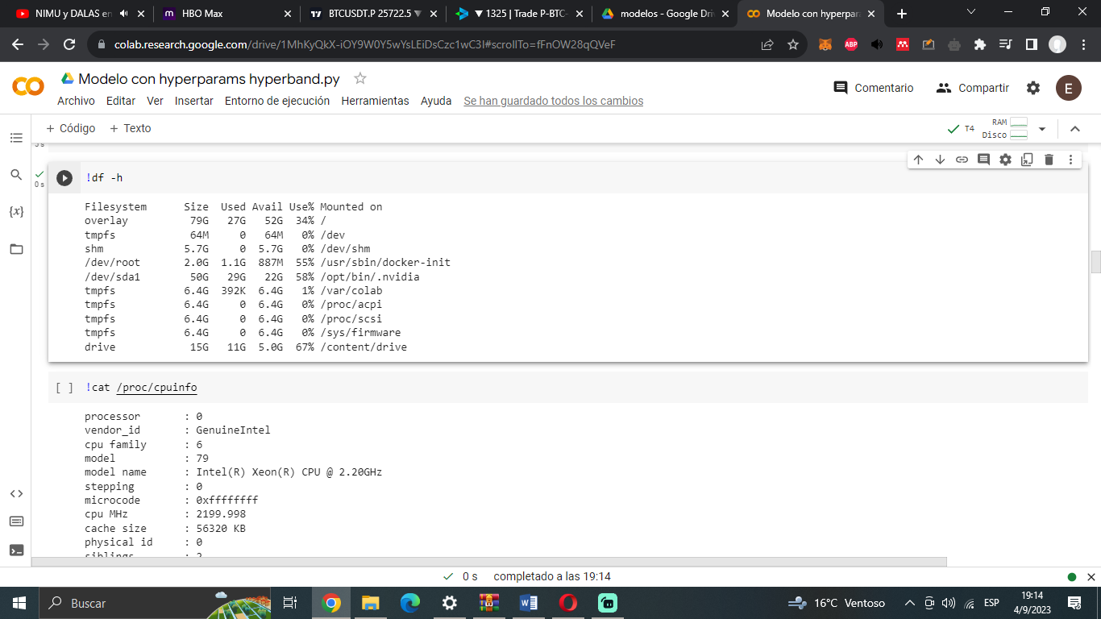

processor : 0

vendor_id : GenuineIntel

cpu family : 6

model : 79

model name : Intel(R) Xeon(R) CPU @ 2.20GHz

stepping : 0

microcode : 0xffffffff

cpu MHz : 2199.998

cache size : 56320 KB

physical id : 0

siblings : 2

core id : 0

cpu cores : 1

apicid : 0

initial apicid : 0

fpu : yes

fpu_exception : yes

cpuid level : 13

wp : yes

flags : fpu vme de pse tsc msr pae mce cx8 apic sep mtrr pge mca cmov pat pse36 clflush mmx fxsr sse sse2 ss ht syscall nx pdpe1gb rdtscp lm constant_tsc rep_good nopl xtopology nonstop_tsc cpuid tsc_known_freq pni pclmulqdq ssse3 fma cx16 pcid sse4_1 sse4_2 x2apic movbe popcnt aes xsave avx f16c rdrand hypervisor lahf_lm abm 3dnowprefetch invpcid_single ssbd ibrs ibpb stibp fsgsbase tsc_adjust bmi1 hle avx2 smep bmi2 erms invpcid rtm rdseed adx smap xsaveopt arat md_clear arch_capabilities

bugs : cpu_meltdown spectre_v1 spectre_v2 spec_store_bypass l1tf mds swapgs taa mmio_stale_data retbleed

bogomips : 4399.99

clflush size : 64

cache_alignment : 64

address sizes : 46 bits physical, 48 bits virtual

power management:

processor : 1

vendor_id : GenuineIntel

cpu family : 6

model : 79

model name : Intel(R) Xeon(R) CPU @ 2.20GHz

stepping : 0

microcode : 0xffffffff

cpu MHz : 2199.998

cache size : 56320 KB

physical id : 0

siblings : 2

core id : 0

cpu cores : 1

apicid : 1

initial apicid : 1

fpu : yes

fpu_exception : yes

cpuid level : 13

wp : yes

flags : fpu vme de pse tsc msr pae mce cx8 apic sep mtrr pge mca cmov pat pse36 clflush mmx fxsr sse sse2 ss ht syscall nx pdpe1gb rdtscp lm constant_tsc rep_good nopl xtopology nonstop_tsc cpuid tsc_known_freq pni pclmulqdq ssse3 fma cx16 pcid sse4_1 sse4_2 x2apic movbe popcnt aes xsave avx f16c rdrand hypervisor lahf_lm abm 3dnowprefetch invpcid_single ssbd ibrs ibpb stibp fsgsbase tsc_adjust bmi1 hle avx2 smep bmi2 erms invpcid rtm rdseed adx smap xsaveopt arat md_clear arch_capabilities

bugs : cpu_meltdown spectre_v1 spectre_v2 spec_store_bypass l1tf mds swapgs taa mmio_stale_data retbleed

bogomips : 4399.99

clflush size : 64

cache_alignment : 64

address sizes : 46 bits physical, 48 bits virtual

power management:

!cat /proc/meminfo

MemTotal: 13294252 kB

MemFree: 7900312 kB

MemAvailable: 11077676 kB

Buffers: 71192 kB

Cached: 3300096 kB

SwapCached: 0 kB

Active: 937824 kB

Inactive: 4181096 kB

Active(anon): 1668 kB

Inactive(anon): 1752180 kB

Active(file): 936156 kB

Inactive(file): 2428916 kB

Unevictable: 12 kB

Mlocked: 12 kB

SwapTotal: 0 kB

SwapFree: 0 kB

Dirty: 852 kB

Writeback: 0 kB

AnonPages: 1737504 kB

Mapped: 570516 kB

Shmem: 6212 kB

KReclaimable: 106492 kB

Slab: 145016 kB

SReclaimable: 106492 kB

SUnreclaim: 38524 kB

KernelStack: 5600 kB

PageTables: 38524 kB

NFS_Unstable: 0 kB

Bounce: 0 kB

WritebackTmp: 0 kB

CommitLimit: 6647124 kB

Committed_AS: 3041904 kB

VmallocTotal: 34359738367 kB

VmallocUsed: 10548 kB

VmallocChunk: 0 kB

Percpu: 1296 kB

HardwareCorrupted: 0 kB

AnonHugePages: 22528 kB

ShmemHugePages: 0 kB

ShmemPmdMapped: 0 kB

FileHugePages: 0 kB

FilePmdMapped: 0 kB

CmaTotal: 0 kB

CmaFree: 0 kB

HugePages_Total: 0

HugePages_Free: 0

HugePages_Rsvd: 0

HugePages_Surp: 0

Hugepagesize: 2048 kB

Hugetlb: 0 kB

DirectMap4k: 78648 kB

DirectMap2M: 5160960 kB

DirectMap1G: 10485760 kB

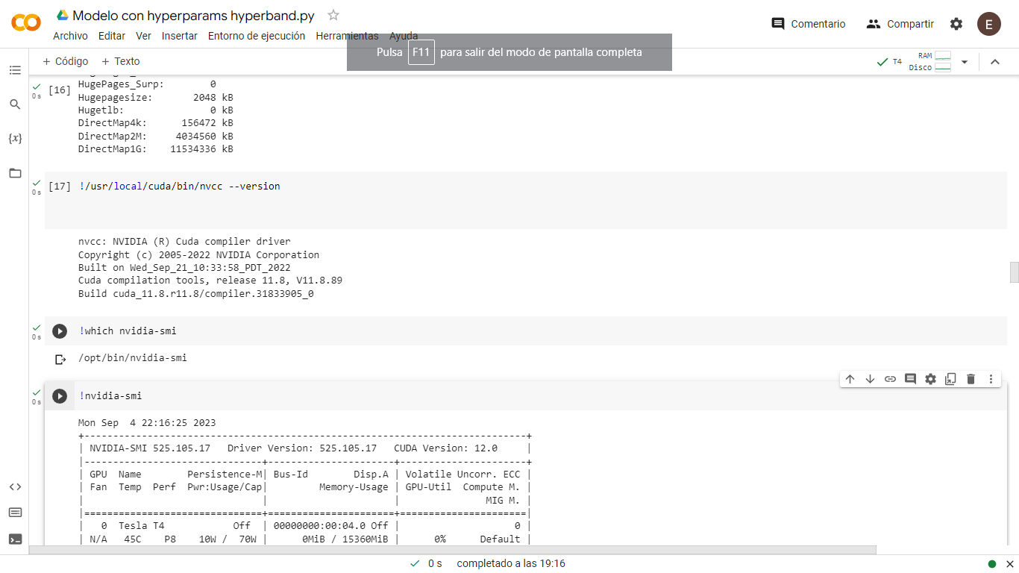

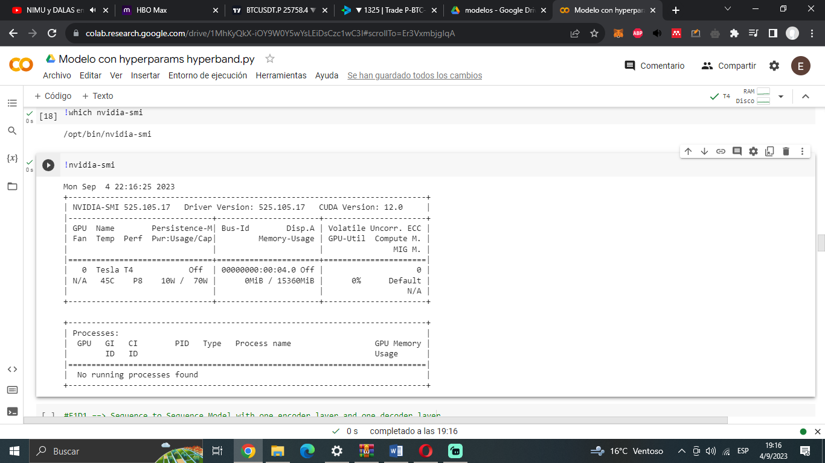

Datos de la segunda ejecución segundo dia

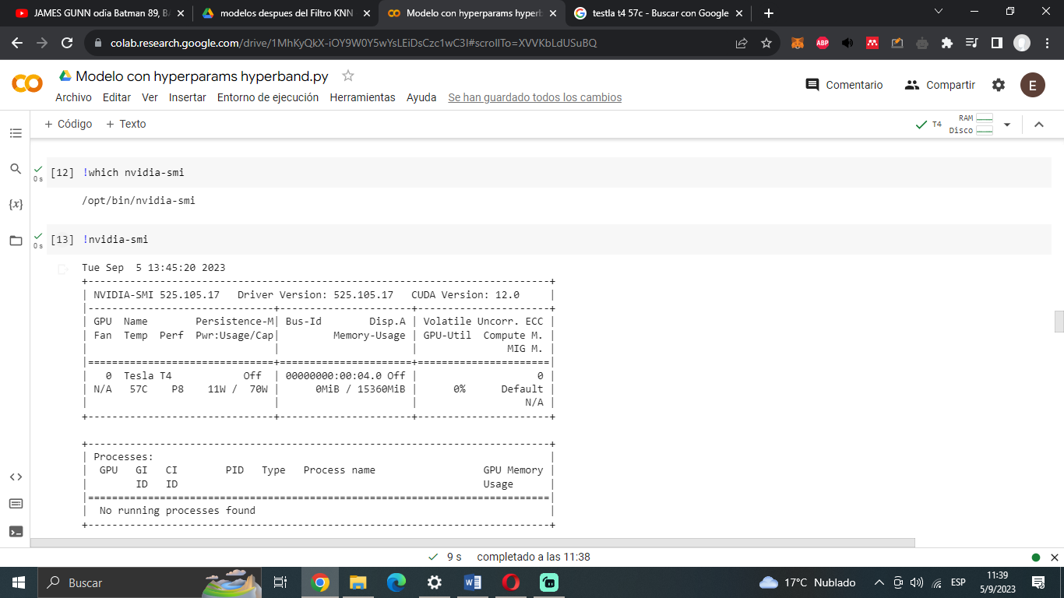

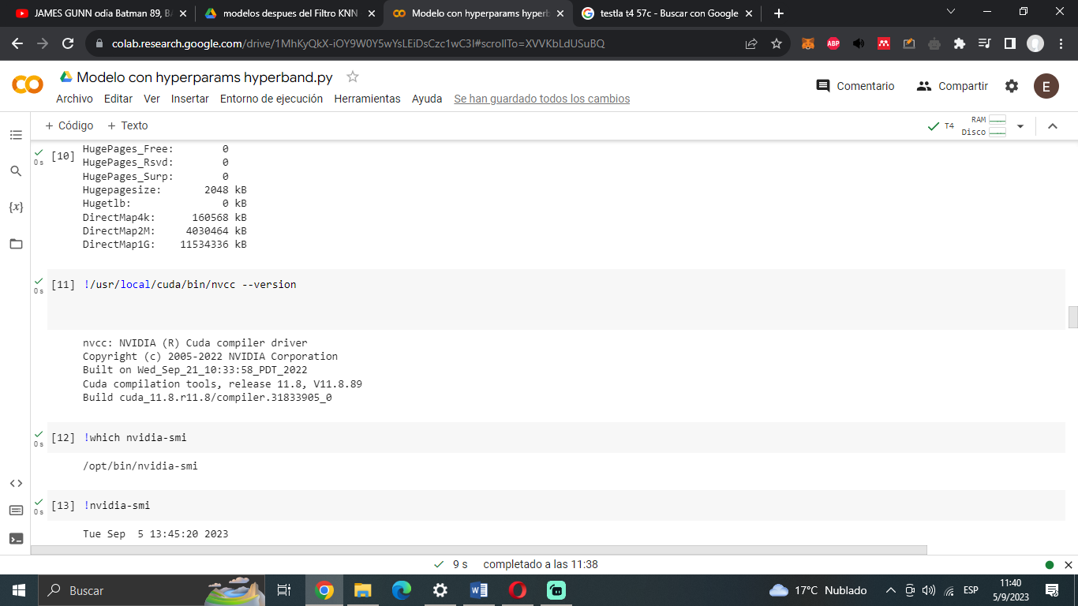

!cat /proc/meminfo

MemTotal: 13294252 kB

MemFree: 9484716 kB

MemAvailable: 11895420 kB

Buffers: 72240 kB

Cached: 2539136 kB

SwapCached: 0 kB

Active: 747316 kB

Inactive: 2779056 kB

Active(anon): 1160 kB

Inactive(anon): 915492 kB

Active(file): 746156 kB

Inactive(file): 1863564 kB

Unevictable: 12 kB

Mlocked: 12 kB

SwapTotal: 0 kB

SwapFree: 0 kB

Dirty: 4656 kB

Writeback: 0 kB

AnonPages: 913924 kB

Mapped: 556328 kB

Shmem: 1652 kB

KReclaimable: 83876 kB

Slab: 122380 kB

SReclaimable: 83876 kB

SUnreclaim: 38504 kB

KernelStack: 5856 kB

PageTables: 15364 kB

NFS_Unstable: 0 kB

Bounce: 0 kB

WritebackTmp: 0 kB

CommitLimit: 6647124 kB

Committed_AS: 2903828 kB

VmallocTotal: 34359738367 kB

VmallocUsed: 74664 kB

VmallocChunk: 0 kB

Percpu: 1296 kB

HardwareCorrupted: 0 kB

AnonHugePages: 24576 kB

ShmemHugePages: 0 kB

ShmemPmdMapped: 0 kB

FileHugePages: 0 kB

FilePmdMapped: 0 kB

CmaTotal: 0 kB

CmaFree: 0 kB

HugePages_Total: 0

HugePages_Free: 0

HugePages_Rsvd: 0

HugePages_Surp: 0

Hugepagesize: 2048 kB

Hugetlb: 0 kB

DirectMap4k: 160568 kB

DirectMap2M: 4030464 kB

DirectMap1G: 11534336 kB

!cat /proc/cpuinfo

processor : 0

vendor_id : GenuineIntel

cpu family : 6

model : 63

model name : Intel(R) Xeon(R) CPU @ 2.30GHz

stepping : 0

microcode : 0xffffffff

cpu MHz : 2299.998

cache size : 46080 KB

physical id : 0

siblings : 2

core id : 0

cpu cores : 1

apicid : 0

initial apicid : 0

fpu : yes

fpu_exception : yes

cpuid level : 13

wp : yes

flags : fpu vme de pse tsc msr pae mce cx8 apic sep mtrr pge mca cmov pat pse36 clflush mmx fxsr sse sse2 ss ht syscall nx pdpe1gb rdtscp lm constant_tsc rep_good nopl xtopology nonstop_tsc cpuid tsc_known_freq pni pclmulqdq ssse3 fma cx16 pcid sse4_1 sse4_2 x2apic movbe popcnt aes xsave avx f16c rdrand hypervisor lahf_lm abm invpcid_single ssbd ibrs ibpb stibp fsgsbase tsc_adjust bmi1 avx2 smep bmi2 erms invpcid xsaveopt arat md_clear arch_capabilities

bugs : cpu_meltdown spectre_v1 spectre_v2 spec_store_bypass l1tf mds swapgs mmio_stale_data retbleed

bogomips : 4599.99

clflush size : 64

cache_alignment : 64

address sizes : 46 bits physical, 48 bits virtual

power management:

processor : 1

vendor_id : GenuineIntel

cpu family : 6

model : 63

model name : Intel(R) Xeon(R) CPU @ 2.30GHz

stepping : 0

microcode : 0xffffffff

cpu MHz : 2299.998

cache size : 46080 KB

physical id : 0

siblings : 2

core id : 0

cpu cores : 1

apicid : 1

initial apicid : 1

fpu : yes

fpu_exception : yes

cpuid level : 13

wp : yes

flags : fpu vme de pse tsc msr pae mce cx8 apic sep mtrr pge mca cmov pat pse36 clflush mmx fxsr sse sse2 ss ht syscall nx pdpe1gb rdtscp lm constant_tsc rep_good nopl xtopology nonstop_tsc cpuid tsc_known_freq pni pclmulqdq ssse3 fma cx16 pcid sse4_1 sse4_2 x2apic movbe popcnt aes xsave avx f16c rdrand hypervisor lahf_lm abm invpcid_single ssbd ibrs ibpb stibp fsgsbase tsc_adjust bmi1 avx2 smep bmi2 erms invpcid xsaveopt arat md_clear arch_capabilities

bugs : cpu_meltdown spectre_v1 spectre_v2 spec_store_bypass l1tf mds swapgs mmio_stale_data retbleed

bogomips : 4599.99

clflush size : 64

cache_alignment : 64

address sizes : 46 bits physical, 48 bits virtual

power management:

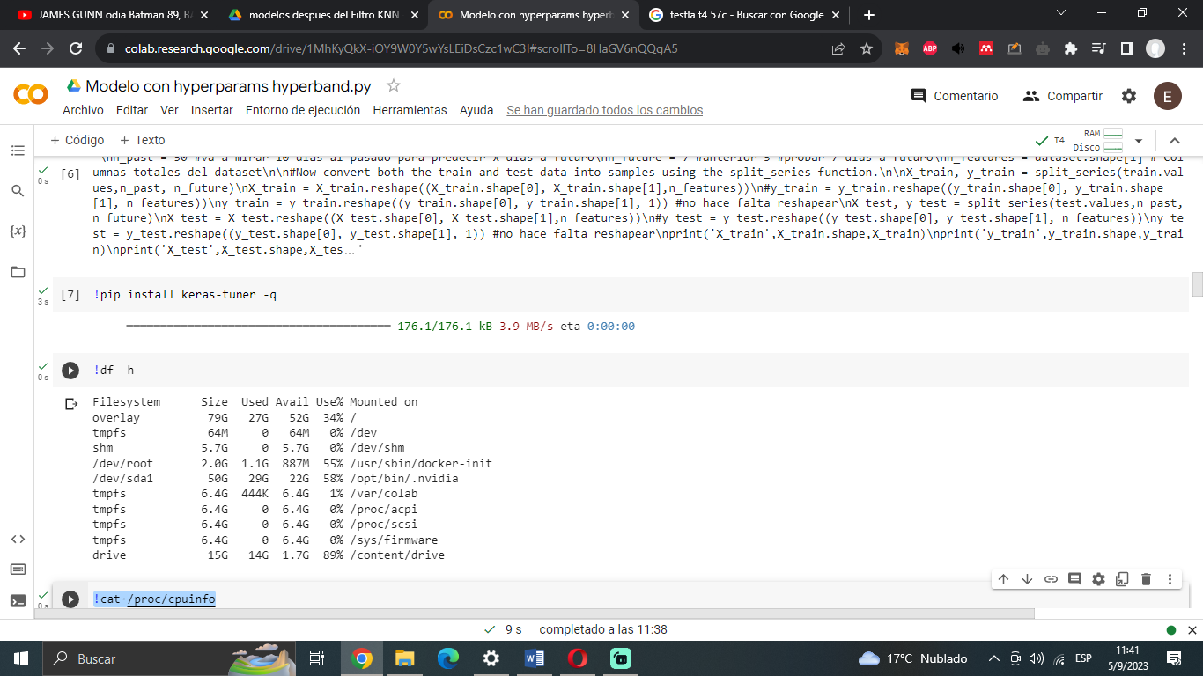

## Resultados hyperband

WARNING:tensorflow:Layer gru_2 will not use cuDNN kernels since it doesn't meet the criteria. It will use a generic GPU kernel as fallback when running on GPU.

WARNING:tensorflow:Layer gru_3 will not use cuDNN kernels since it doesn't meet the criteria. It will use a generic GPU kernel as fallback when running on GPU.

n_days 7 {'units': 128, 'lr': 0.007402925076656829, 'dropout': 0.4, 'recurrent_dropout': 0.1, 'batch_size': 128, 'tuner/epochs': 50, 'tuner/initial_epoch': 17, 'tuner/bracket': 1, 'tuner/round': 1, 'tuner/trial_id': '0079'}

otro 7 <class '__main__.MyTuner'>

Results summary

Results in /content/drive/MyDrive/a Tesis de Grado/Tesis Versiones/tesis2023/modelos /salidasModelosHypertuner/hyperband/SMAPE-max_trials50- epochs100-aleatorio 7

Showing 1 best trials

Objective(name="val_loss", direction="min")

Trial 0082 summary

Hyperparameters:

units: 128

lr: 0.007402925076656829

dropout: 0.4

recurrent_dropout: 0.1

batch_size: 128

tuner/epochs: 50

tuner/initial_epoch: 17

tuner/bracket: 1

tuner/round: 1

tuner/trial_id: 0079

Score: 0.083434097468853

results_summary <class 'NoneType'>

WARNING:tensorflow:Layer gru_3 will not use cuDNN kernels since it doesn't meet the criteria. It will use a generic GPU kernel as fallback when running on GPU.

n_days 14 {'units': 448, 'lr': 0.0020843011585253736, 'dropout': 0.30000000000000004, 'recurrent_dropout': 0.4, 'batch_size': 64, 'tuner/epochs': 50, 'tuner/initial_epoch': 17, 'tuner/bracket': 2, 'tuner/round': 2, 'tuner/trial_id': '0071'}

otro 14 <class '__main__.MyTuner'>

WARNING:tensorflow:Detecting that an object or model or tf.train.Checkpoint is being deleted with unrestored values. See the following logs for the specific values in question. To silence these warnings, use `status.expect_partial()`. See <https://www.tensorflow.org/api_docs/python/tf/train/Checkpoint#restorefor> details about the status object returned by the restore function.

WARNING:tensorflow:Detecting that an object or model or tf.train.Checkpoint is being deleted with unrestored values. See the following logs for the specific values in question. To silence these warnings, use `status.expect_partial()`. See <https://www.tensorflow.org/api_docs/python/tf/train/Checkpoint#restorefor> details about the status object returned by the restore function.

Results summary

Results in /content/drive/MyDrive/a Tesis de Grado/Tesis Versiones/tesis2023/modelos /salidasModelosHypertuner/hyperband/SMAPE-max_trials50- epochs100-aleatorio 14

Showing 1 best trials

Objective(name="val_loss", direction="min")

Trial 0072 summary

Hyperparameters:

units: 448

lr: 0.0020843011585253736

dropout: 0.30000000000000004

recurrent_dropout: 0.4

batch_size: 64

tuner/epochs: 50

tuner/initial_epoch: 17

tuner/bracket: 2

tuner/round: 2

tuner/trial_id: 0071

Score: 0.0839906632900238

results_summary <class 'NoneType'>

n_days 21 {'units': 320, 'lr': 0.00020176544783741468, 'dropout': 0.2, 'recurrent_dropout': 0.0, 'batch_size': 32, 'tuner/epochs': 50, 'tuner/initial_epoch': 0, 'tuner/bracket': 0, 'tuner/round': 0}

otro 21 <class '__main__.MyTuner'>

WARNING:tensorflow:Layer gru_2 will not use cuDNN kernels since it doesn't meet the criteria. It will use a generic GPU kernel as fallback when running on GPU.

WARNING:tensorflow:Detecting that an object or model or tf.train.Checkpoint is being deleted with unrestored values. See the following logs for the specific values in question. To silence these warnings, use `status.expect_partial()`. See <https://www.tensorflow.org/api_docs/python/tf/train/Checkpoint#restorefor> details about the status object returned by the restore function.

WARNING:tensorflow:Detecting that an object or model or tf.train.Checkpoint is being deleted with unrestored values. See the following logs for the specific values in question. To silence these warnings, use `status.expect_partial()`. See <https://www.tensorflow.org/api_docs/python/tf/train/Checkpoint#restorefor> details about the status object returned by the restore function.

Results summary

Results in /content/drive/MyDrive/a Tesis de Grado/Tesis Versiones/tesis2023/modelos /salidasModelosHypertuner/hyperband/SMAPE-max_trials50- epochs100-aleatorio 21

Showing 1 best trials

Objective(name="val_loss", direction="min")

Trial 0087 summary

Hyperparameters:

units: 320

lr: 0.00020176544783741468

dropout: 0.2

recurrent_dropout: 0.0

batch_size: 32

tuner/epochs: 50

tuner/initial_epoch: 0

tuner/bracket: 0

tuner/round: 0

Score: 0.07927556335926056

results_summary <class 'NoneType'>

n_days 28 {'units': 416, 'lr': 0.0015323427281788212, 'dropout': 0.1, 'recurrent_dropout': 0.1, 'batch_size': 32, 'tuner/epochs': 17, 'tuner/initial_epoch': 6, 'tuner/bracket': 2, 'tuner/round': 1, 'tuner/trial_id': '0053'}

otro 28 <class '__main__.MyTuner'>

Results summary

Results in /content/drive/MyDrive/a Tesis de Grado/Tesis Versiones/tesis2023/modelos /salidasModelosHypertuner/hyperband/SMAPE-max_trials50- epochs100-aleatorio 28

Showing 1 best trials

Objective(name="val_loss", direction="min")

Trial 0068 summary

Hyperparameters:

units: 416

lr: 0.0015323427281788212

dropout: 0.1

recurrent_dropout: 0.1

batch_size: 32

tuner/epochs: 17

tuner/initial_epoch: 6

tuner/bracket: 2

tuner/round: 1

tuner/trial_id: 0053

Score: 0.07861421257257462

results_summary <class 'NoneType'>

## Algoritmo randomsearch

Tiempo inicio 17:53 05-09-2023

Parada a 21:35 05-09-2023 falta terminar

Ejecuto devuelta 11:12 06-09-2023

Finalizo a las 2023-09-06 12:40:26

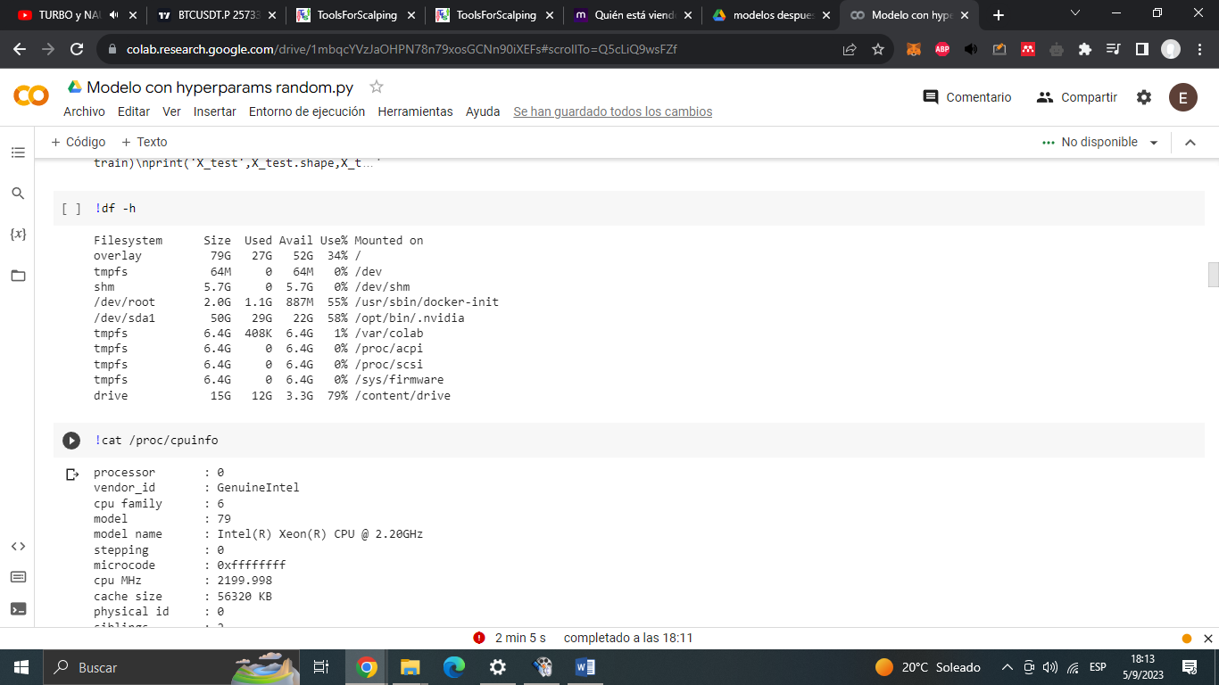

!cat /proc/cpuinfo

processor : 0

vendor_id : GenuineIntel

cpu family : 6

model : 79

model name : Intel(R) Xeon(R) CPU @ 2.20GHz

stepping : 0

microcode : 0xffffffff

cpu MHz : 2199.998

cache size : 56320 KB

physical id : 0

siblings : 2

core id : 0

cpu cores : 1

apicid : 0

initial apicid : 0

fpu : yes

fpu_exception : yes

cpuid level : 13

wp : yes

flags : fpu vme de pse tsc msr pae mce cx8 apic sep mtrr pge mca cmov pat pse36 clflush mmx fxsr sse sse2 ss ht syscall nx pdpe1gb rdtscp lm constant_tsc rep_good nopl xtopology nonstop_tsc cpuid tsc_known_freq pni pclmulqdq ssse3 fma cx16 pcid sse4_1 sse4_2 x2apic movbe popcnt aes xsave avx f16c rdrand hypervisor lahf_lm abm 3dnowprefetch invpcid_single ssbd ibrs ibpb stibp fsgsbase tsc_adjust bmi1 hle avx2 smep bmi2 erms invpcid rtm rdseed adx smap xsaveopt arat md_clear arch_capabilities

bugs : cpu_meltdown spectre_v1 spectre_v2 spec_store_bypass l1tf mds swapgs taa mmio_stale_data retbleed

bogomips : 4399.99

clflush size : 64

cache_alignment : 64

address sizes : 46 bits physical, 48 bits virtual

power management:

processor : 1

vendor_id : GenuineIntel

cpu family : 6

model : 79

model name : Intel(R) Xeon(R) CPU @ 2.20GHz

stepping : 0

microcode : 0xffffffff

cpu MHz : 2199.998

cache size : 56320 KB

physical id : 0

siblings : 2

core id : 0

cpu cores : 1

apicid : 1

initial apicid : 1

fpu : yes

fpu_exception : yes

cpuid level : 13

wp : yes

flags : fpu vme de pse tsc msr pae mce cx8 apic sep mtrr pge mca cmov pat pse36 clflush mmx fxsr sse sse2 ss ht syscall nx pdpe1gb rdtscp lm constant_tsc rep_good nopl xtopology nonstop_tsc cpuid tsc_known_freq pni pclmulqdq ssse3 fma cx16 pcid sse4_1 sse4_2 x2apic movbe popcnt aes xsave avx f16c rdrand hypervisor lahf_lm abm 3dnowprefetch invpcid_single ssbd ibrs ibpb stibp fsgsbase tsc_adjust bmi1 hle avx2 smep bmi2 erms invpcid rtm rdseed adx smap xsaveopt arat md_clear arch_capabilities

bugs : cpu_meltdown spectre_v1 spectre_v2 spec_store_bypass l1tf mds swapgs taa mmio_stale_data retbleed

bogomips : 4399.99

clflush size : 64

cache_alignment : 64

address sizes : 46 bits physical, 48 bits virtual

power management:

!cat /proc/meminfo

MemTotal: 13294252 kB

MemFree: 9098632 kB

MemAvailable: 11469388 kB

Buffers: 71124 kB

Cached: 2500784 kB

SwapCached: 0 kB

Active: 760560 kB

Inactive: 3132628 kB

Active(anon): 1236 kB

Inactive(anon): 1321664 kB

Active(file): 759324 kB

Inactive(file): 1810964 kB

Unevictable: 12 kB

Mlocked: 12 kB

SwapTotal: 0 kB

SwapFree: 0 kB

Dirty: 4552 kB

Writeback: 0 kB

AnonPages: 1321312 kB

Mapped: 559604 kB

Shmem: 1616 kB

KReclaimable: 82848 kB

Slab: 122236 kB

SReclaimable: 82848 kB

SUnreclaim: 39388 kB

KernelStack: 5712 kB

PageTables: 31776 kB

NFS_Unstable: 0 kB

Bounce: 0 kB

WritebackTmp: 0 kB

CommitLimit: 6647124 kB

Committed_AS: 2943308 kB

VmallocTotal: 34359738367 kB

VmallocUsed: 74504 kB

VmallocChunk: 0 kB

Percpu: 1320 kB

HardwareCorrupted: 0 kB

AnonHugePages: 0 kB

ShmemHugePages: 0 kB

ShmemPmdMapped: 0 kB

FileHugePages: 0 kB

FilePmdMapped: 0 kB

CmaTotal: 0 kB

CmaFree: 0 kB

HugePages_Total: 0

HugePages_Free: 0

HugePages_Rsvd: 0

HugePages_Surp: 0

Hugepagesize: 2048 kB

Hugetlb: 0 kB

DirectMap4k: 168760 kB

DirectMap2M: 5070848 kB

DirectMap1G: 10485760 kB

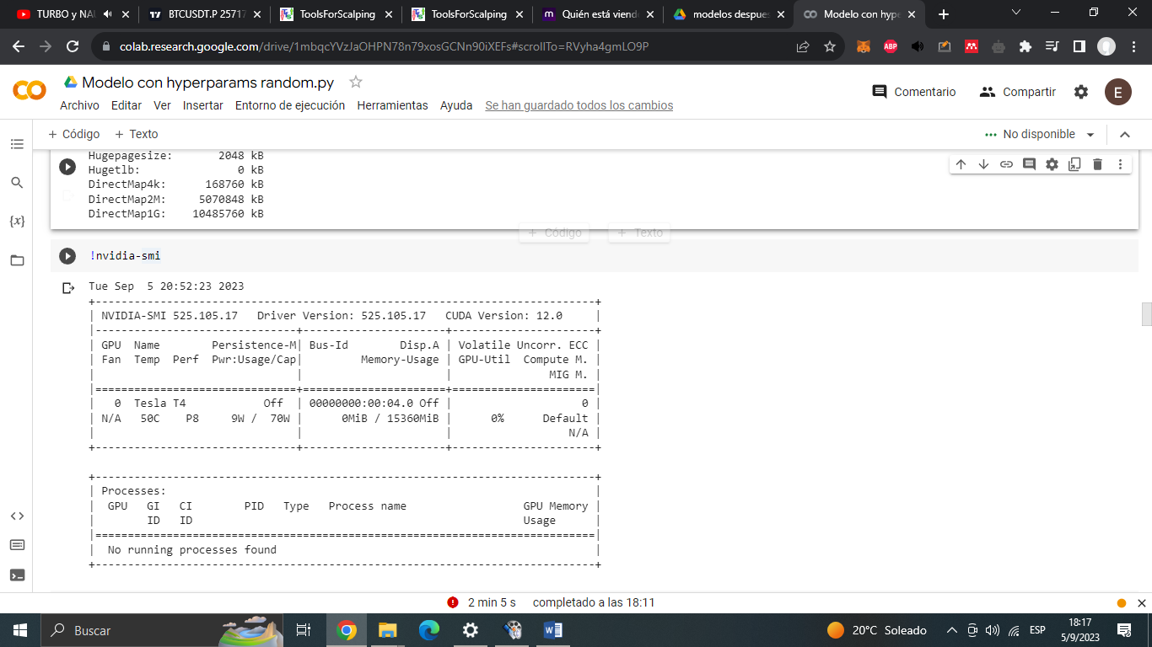

### Datos segunda ejecución

!df -h

Filesystem Size Used Avail Use% Mounted on

overlay 79G 27G 52G 34% /

tmpfs 64M 0 64M 0% /dev

shm 5.7G 0 5.7G 0% /dev/shm

/dev/root 2.0G 1.1G 887M 55% /usr/sbin/docker-init

tmpfs 6.4G 80K 6.4G 1% /var/colab

/dev/sda1 50G 29G 22G 58% /opt/bin/.nvidia

tmpfs 6.4G 0 6.4G 0% /proc/acpi

tmpfs 6.4G 0 6.4G 0% /proc/scsi

tmpfs 6.4G 0 6.4G 0% /sys/firmware

drive 15G 9.5G 5.6G 64% /content/drive

!cat /proc/cpuinfo

processor : 0

vendor_id : GenuineIntel

cpu family : 6

model : 79

model name : Intel(R) Xeon(R) CPU @ 2.20GHz

stepping : 0

microcode : 0xffffffff

cpu MHz : 2199.998

cache size : 56320 KB

physical id : 0

siblings : 2

core id : 0

cpu cores : 1

apicid : 0

initial apicid : 0

fpu : yes

fpu_exception : yes

cpuid level : 13

wp : yes

flags : fpu vme de pse tsc msr pae mce cx8 apic sep mtrr pge mca cmov pat pse36 clflush mmx fxsr sse sse2 ss ht syscall nx pdpe1gb rdtscp lm constant_tsc rep_good nopl xtopology nonstop_tsc cpuid tsc_known_freq pni pclmulqdq ssse3 fma cx16 pcid sse4_1 sse4_2 x2apic movbe popcnt aes xsave avx f16c rdrand hypervisor lahf_lm abm 3dnowprefetch invpcid_single ssbd ibrs ibpb stibp fsgsbase tsc_adjust bmi1 hle avx2 smep bmi2 erms invpcid rtm rdseed adx smap xsaveopt arat md_clear arch_capabilities

bugs : cpu_meltdown spectre_v1 spectre_v2 spec_store_bypass l1tf mds swapgs taa mmio_stale_data retbleed

bogomips : 4399.99

clflush size : 64

cache_alignment : 64

address sizes : 46 bits physical, 48 bits virtual

power management:

processor : 1

vendor_id : GenuineIntel

cpu family : 6

model : 79

model name : Intel(R) Xeon(R) CPU @ 2.20GHz

stepping : 0

microcode : 0xffffffff

cpu MHz : 2199.998

cache size : 56320 KB

physical id : 0

siblings : 2

core id : 0

cpu cores : 1

apicid : 1

initial apicid : 1

fpu : yes

fpu_exception : yes

cpuid level : 13

wp : yes

flags : fpu vme de pse tsc msr pae mce cx8 apic sep mtrr pge mca cmov pat pse36 clflush mmx fxsr sse sse2 ss ht syscall nx pdpe1gb rdtscp lm constant_tsc rep_good nopl xtopology nonstop_tsc cpuid tsc_known_freq pni pclmulqdq ssse3 fma cx16 pcid sse4_1 sse4_2 x2apic movbe popcnt aes xsave avx f16c rdrand hypervisor lahf_lm abm 3dnowprefetch invpcid_single ssbd ibrs ibpb stibp fsgsbase tsc_adjust bmi1 hle avx2 smep bmi2 erms invpcid rtm rdseed adx smap xsaveopt arat md_clear arch_capabilities

bugs : cpu_meltdown spectre_v1 spectre_v2 spec_store_bypass l1tf mds swapgs taa mmio_stale_data retbleed

bogomips : 4399.99

clflush size : 64

cache_alignment : 64

address sizes : 46 bits physical, 48 bits virtual

power management:

!cat /proc/meminfo

MemTotal: 13294252 kB

MemFree: 9157584 kB

MemAvailable: 11524216 kB

Buffers: 70740 kB

Cached: 2496712 kB

SwapCached: 0 kB

Active: 749608 kB

Inactive: 3076584 kB

Active(anon): 1072 kB

Inactive(anon): 1258960 kB

Active(file): 748536 kB

Inactive(file): 1817624 kB

Unevictable: 12 kB

Mlocked: 12 kB

SwapTotal: 0 kB

SwapFree: 0 kB

Dirty: 6116 kB

Writeback: 0 kB

AnonPages: 1258808 kB

Mapped: 562140 kB

Shmem: 1288 kB

KReclaimable: 82856 kB

Slab: 121748 kB

SReclaimable: 82856 kB

SUnreclaim: 38892 kB

KernelStack: 5952 kB

PageTables: 25648 kB

NFS_Unstable: 0 kB

Bounce: 0 kB

WritebackTmp: 0 kB

CommitLimit: 6647124 kB

Committed_AS: 2932136 kB

VmallocTotal: 34359738367 kB

VmallocUsed: 74760 kB

VmallocChunk: 0 kB

Percpu: 1296 kB

HardwareCorrupted: 0 kB

AnonHugePages: 0 kB

ShmemHugePages: 0 kB

ShmemPmdMapped: 0 kB

FileHugePages: 0 kB

FilePmdMapped: 0 kB

CmaTotal: 0 kB

CmaFree: 0 kB

HugePages_Total: 0

HugePages_Free: 0

HugePages_Rsvd: 0

HugePages_Surp: 0

Hugepagesize: 2048 kB

Hugetlb: 0 kB

DirectMap4k: 164664 kB

DirectMap2M: 5074944 kB

DirectMap1G: 10485760 kB

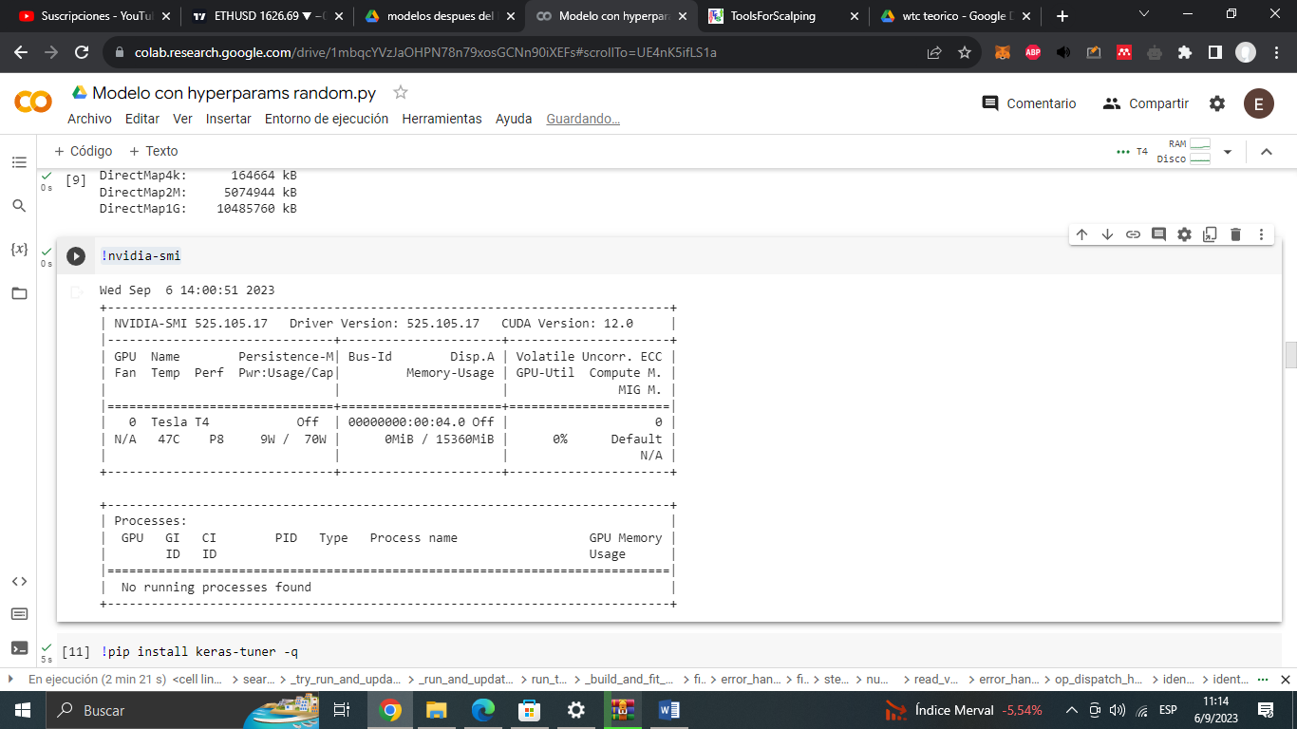

## Resultados Random search

WARNING:tensorflow:Layer gru_2 will not use cuDNN kernels since it doesn't meet the criteria. It will use a generic GPU kernel as fallback when running on GPU.

WARNING:tensorflow:Layer gru_3 will not use cuDNN kernels since it doesn't meet the criteria. It will use a generic GPU kernel as fallback when running on GPU.

n_days 7 {'units': 288, 'lr': 0.001325242185767969, 'dropout': 0.4, 'recurrent_dropout': 0.2, 'batch_size': 128}

otro 7 <class 'keras_tuner.tuners.randomsearch.RandomSearch'>

Results summary

Results in /content/drive/MyDrive/a Tesis de Grado/Tesis Versiones/tesis2023/modelos /salidasModelosHypertuner/randomSearch/SMAPE-max_trials50- epochs100-aleatorio 7

Showing 1 best trials

Objective(name="val_loss", direction="min")

Trial 06 summary

Hyperparameters:

units: 288

lr: 0.001325242185767969

dropout: 0.4

recurrent_dropout: 0.2

batch_size: 128

Score: 0.0834403708577156

results_summary <class 'NoneType'>

n_days 14 {'units': 224, 'lr': 0.00036448699004144517, 'dropout': 0.1, 'recurrent_dropout': 0.1, 'batch_size': 32}

otro 14 <class 'keras_tuner.tuners.randomsearch.RandomSearch'>

WARNING:tensorflow:Layer gru will not use cuDNN kernels since it doesn't meet the criteria. It will use a generic GPU kernel as fallback when running on GPU.

WARNING:tensorflow:Layer gru_1 will not use cuDNN kernels since it doesn't meet the criteria. It will use a generic GPU kernel as fallback when running on GPU.

WARNING:tensorflow:Layer gru_2 will not use cuDNN kernels since it doesn't meet the criteria. It will use a generic GPU kernel as fallback when running on GPU.

WARNING:tensorflow:Detecting that an object or model or tf.train.Checkpoint is being deleted with unrestored values. See the following logs for the specific values in question. To silence these warnings, use `status.expect_partial()`. See <https://www.tensorflow.org/api_docs/python/tf/train/Checkpoint#restorefor> details about the status object returned by the restore function.

Results summary

Results in /content/drive/MyDrive/a Tesis de Grado/Tesis Versiones/tesis2023/modelos /salidasModelosHypertuner/randomSearch/SMAPE-max_trials50- epochs100-aleatorio 14

Showing 1 best trials

Objective(name="val_loss", direction="min")

Trial 10 summary

Hyperparameters:

units: 224

lr: 0.00036448699004144517

dropout: 0.1

recurrent_dropout: 0.1

batch_size: 32

Score: 0.08397094905376434

results_summary <class 'NoneType'>

WARNING:tensorflow:Layer gru_3 will not use cuDNN kernels since it doesn't meet the criteria. It will use a generic GPU kernel as fallback when running on GPU.

n_days 21 {'units': 352, 'lr': 0.0018500304177758314, 'dropout': 0.2, 'recurrent_dropout': 0.4, 'batch_size': 32}

otro 21 <class 'keras_tuner.tuners.randomsearch.RandomSearch'>

WARNING:tensorflow:Detecting that an object or model or tf.train.Checkpoint is being deleted with unrestored values. See the following logs for the specific values in question. To silence these warnings, use `status.expect_partial()`. See <https://www.tensorflow.org/api_docs/python/tf/train/Checkpoint#restorefor> details about the status object returned by the restore function.

WARNING:tensorflow:Value in checkpoint could not be found in the restored object: (root).optimizer._variables.15

WARNING:tensorflow:Value in checkpoint could not be found in the restored object: (root).optimizer._variables.16

Results summary

Results in /content/drive/MyDrive/a Tesis de Grado/Tesis Versiones/tesis2023/modelos /salidasModelosHypertuner/randomSearch/SMAPE-max_trials50- epochs100-aleatorio 21

Showing 1 best trials

Objective(name="val_loss", direction="min")

Trial 22 summary

Hyperparameters:

units: 352

lr: 0.0018500304177758314

dropout: 0.2

recurrent_dropout: 0.4

batch_size: 32

Score: 0.07923400402069092

results_summary <class 'NoneType'>

n_days 28 {'units': 384, 'lr': 0.001458062655405858, 'dropout': 0.1, 'recurrent_dropout': 0.0, 'batch_size': 96}

otro 28 <class 'keras_tuner.tuners.randomsearch.RandomSearch'>

WARNING:tensorflow:Detecting that an object or model or tf.train.Checkpoint is being deleted with unrestored values. See the following logs for the specific values in question. To silence these warnings, use `status.expect_partial()`. See <https://www.tensorflow.org/api_docs/python/tf/train/Checkpoint#restorefor> details about the status object returned by the restore function.

Results summary

Results in /content/drive/MyDrive/a Tesis de Grado/Tesis Versiones/tesis2023/modelos /salidasModelosHypertuner/randomSearch/SMAPE-max_trials50- epochs100-aleatorio 28

Showing 1 best trials

Objective(name="val_loss", direction="min")

Trial 18 summary

Hyperparameters:

units: 384

lr: 0.001458062655405858

dropout: 0.1

recurrent_dropout: 0.0

batch_size: 96

Score: 0.07861848175525665

results_summary <class 'NoneType'>

## Algoritmo bayesian

Tiempo inicio 18:11 16-09-2023

Finalizo a las 2023-09-16 19:17:34

Ejecuto devuelta -

Finalizo a las -

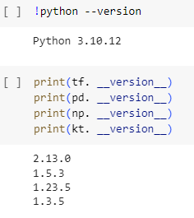

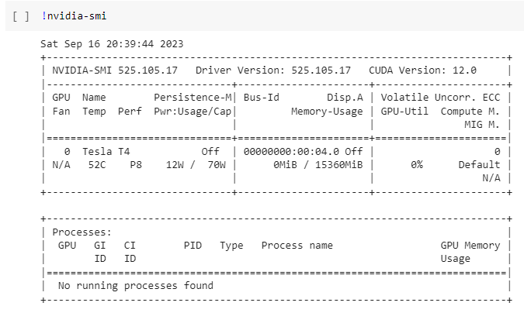

!cat /proc/meminfo

MemTotal: 13294252 kB

MemFree: 9777852 kB

MemAvailable: 12137828 kB

Buffers: 71496 kB

Cached: 2488424 kB

SwapCached: 0 kB

Active: 757080 kB

Inactive: 2473344 kB

Active(anon): 1116 kB

Inactive(anon): 670856 kB

Active(file): 755964 kB

Inactive(file): 1802488 kB

Unevictable: 12 kB

Mlocked: 12 kB

SwapTotal: 0 kB

SwapFree: 0 kB

Dirty: 5460 kB

Writeback: 0 kB

AnonPages: 670708 kB

Mapped: 570916 kB

Shmem: 1332 kB

KReclaimable: 84960 kB

Slab: 124272 kB

SReclaimable: 84960 kB

SUnreclaim: 39312 kB

KernelStack: 5904 kB

PageTables: 9116 kB

NFS_Unstable: 0 kB

Bounce: 0 kB

WritebackTmp: 0 kB

CommitLimit: 6647124 kB

Committed_AS: 2902444 kB

VmallocTotal: 34359738367 kB

VmallocUsed: 74712 kB

VmallocChunk: 0 kB

Percpu: 1320 kB

HardwareCorrupted: 0 kB

AnonHugePages: 0 kB

ShmemHugePages: 0 kB

ShmemPmdMapped: 0 kB

FileHugePages: 0 kB

FilePmdMapped: 0 kB

CmaTotal: 0 kB

CmaFree: 0 kB

HugePages_Total: 0

HugePages_Free: 0

HugePages_Rsvd: 0

HugePages_Surp: 0

Hugepagesize: 2048 kB

Hugetlb: 0 kB

DirectMap4k: 152376 kB

DirectMap2M: 5087232 kB

DirectMap1G: 10485760 kB

!cat /proc/cpuinfo

processor : 0

vendor_id : GenuineIntel

cpu family : 6

model : 85

model name : Intel(R) Xeon(R) CPU @ 2.00GHz

stepping : 3

microcode : 0xffffffff

cpu MHz : 2000.156

cache size : 39424 KB

physical id : 0

siblings : 2

core id : 0

cpu cores : 1

apicid : 0

initial apicid : 0

fpu : yes

fpu_exception : yes

cpuid level : 13

wp : yes

flags : fpu vme de pse tsc msr pae mce cx8 apic sep mtrr pge mca cmov pat pse36 clflush mmx fxsr sse sse2 ss ht syscall nx pdpe1gb rdtscp lm constant_tsc rep_good nopl xtopology nonstop_tsc cpuid tsc_known_freq pni pclmulqdq ssse3 fma cx16 pcid sse4_1 sse4_2 x2apic movbe popcnt aes xsave avx f16c rdrand hypervisor lahf_lm abm 3dnowprefetch invpcid_single ssbd ibrs ibpb stibp fsgsbase tsc_adjust bmi1 hle avx2 smep bmi2 erms invpcid rtm mpx avx512f avx512dq rdseed adx smap clflushopt clwb avx512cd avx512bw avx512vl xsaveopt xsavec xgetbv1 xsaves arat md_clear arch_capabilities

bugs : cpu_meltdown spectre_v1 spectre_v2 spec_store_bypass l1tf mds swapgs taa mmio_stale_data retbleed

bogomips : 4000.31

clflush size : 64

cache_alignment : 64

address sizes : 46 bits physical, 48 bits virtual

power management:

processor : 1

vendor_id : GenuineIntel

cpu family : 6

model : 85

model name : Intel(R) Xeon(R) CPU @ 2.00GHz

stepping : 3

microcode : 0xffffffff

cpu MHz : 2000.156

cache size : 39424 KB

physical id : 0

siblings : 2

core id : 0

cpu cores : 1

apicid : 1

initial apicid : 1

fpu : yes

fpu_exception : yes

cpuid level : 13

wp : yes

flags : fpu vme de pse tsc msr pae mce cx8 apic sep mtrr pge mca cmov pat pse36 clflush mmx fxsr sse sse2 ss ht syscall nx pdpe1gb rdtscp lm constant_tsc rep_good nopl xtopology nonstop_tsc cpuid tsc_known_freq pni pclmulqdq ssse3 fma cx16 pcid sse4_1 sse4_2 x2apic movbe popcnt aes xsave avx f16c rdrand hypervisor lahf_lm abm 3dnowprefetch invpcid_single ssbd ibrs ibpb stibp fsgsbase tsc_adjust bmi1 hle avx2 smep bmi2 erms invpcid rtm mpx avx512f avx512dq rdseed adx smap clflushopt clwb avx512cd avx512bw avx512vl xsaveopt xsavec xgetbv1 xsaves arat md_clear arch_capabilities

bugs : cpu_meltdown spectre_v1 spectre_v2 spec_store_bypass l1tf mds swapgs taa mmio_stale_data retbleed

bogomips : 4000.31

clflush size : 64

cache_alignment : 64

address sizes : 46 bits physical, 48 bits virtual

power management:

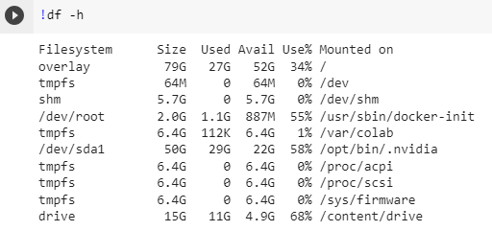

## Resultados Bayesian

/usr/local/lib/python3.10/dist-packages/keras/src/engine/training.py:3000: UserWarning: You are saving your model as an HDF5 file via `model.save()`. This file format is considered legacy. We recommend using instead the native Keras format, e.g. `model.save('my_model.keras')`.

saving_api.save_model(

n_days 7 {'units': 192, 'lr': 0.006393906070076579, 'batch_size': 128}

otro 7 <class '__main__.MyTuner'>

Results summary

Results in /content/drive/MyDrive/a Tesis de Grado/Tesis Versiones/tesis2023/modelos /salidasModelosHypertuner/bayesian/SMAPE-max_trials50- epochs100 7

Showing 1 best trials

Objective(name="val_loss", direction="min")

Trial 28 summary

Hyperparameters:

units: 192

lr: 0.006393906070076579

batch_size: 128

Score: 0.08344161510467529

results_summary <class 'NoneType'>

n_days 14 {'units': 128, 'lr': 0.006857381702631722, 'batch_size': 128}

otro 14 <class '__main__.MyTuner'>

Results summary

Results in /content/drive/MyDrive/a Tesis de Grado/Tesis Versiones/tesis2023/modelos /salidasModelosHypertuner/bayesian/SMAPE-max_trials50- epochs100 14

Showing 1 best trials

Objective(name="val_loss", direction="min")

Trial 29 summary

Hyperparameters:

units: 128

lr: 0.006857381702631722

batch_size: 128

Score: 0.08394590765237808

results_summary <class 'NoneType'>

n_days 21 {'units': 288, 'lr': 0.001955277105279712, 'batch_size': 32}

otro 21 <class '__main__.MyTuner'>

Results summary

Results in /content/drive/MyDrive/a Tesis de Grado/Tesis Versiones/tesis2023/modelos /salidasModelosHypertuner/bayesian/SMAPE-max_trials50- epochs100 21

Showing 1 best trials

Objective(name="val_loss", direction="min")

Trial 28 summary

Hyperparameters:

units: 288

lr: 0.001955277105279712

batch_size: 32

Score: 0.07925496995449066

results_summary <class 'NoneType'>

n_days 28 {'units': 128, 'lr': 0.009197912608294253, 'batch_size': 128}

otro 28 <class '__main__.MyTuner'>

Results summary

Results in /content/drive/MyDrive/a Tesis de Grado/Tesis Versiones/tesis2023/modelos /salidasModelosHypertuner/bayesian/SMAPE-max_trials50- epochs100 28

Showing 1 best trials

Objective(name="val_loss", direction="min")

Trial 17 summary

Hyperparameters:

units: 128

lr: 0.009197912608294253

batch_size: 128

Score: 0.07863243669271469

results_summary <class 'NoneType'>

# Resumen de Resultados

|  |  |  |
| --- | --- | --- |
| Algoritmo | Score | N_days para atrás |
| Bayesian | 0.07863243669271469 | 28 |
| Random Search | 0.07861848175525665 | 28 |
| Hyperband | 0.07861421257257462 | 28 |

Conclusión los tres tuvieron resultados parecidos pero el mejor algoritmo es hyperband ahora probare la siguiente configuración:

N_days=35

N_days=42

Ambos Cada trial tendrá 100 epochs y se probara con 50 trials

10-100

90/30=rango de cada etiqueta

Lo que no puedo argumentar antes el predictor flag era 30 (no sé porque 30) ahora es 15(porque con 30 eran malos resultados)

# Ejecución Hyperband 35 y 42

Tiempo inicio 10:26 20-09-2023

Finalizo a las 2023-09-20 12:28:58

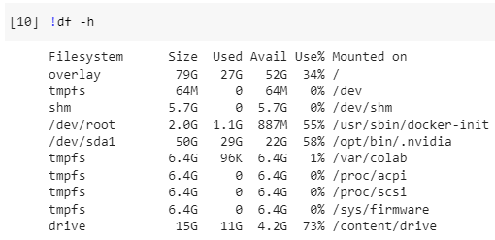

!cat /proc/cpuinfo

processor : 0

vendor_id : GenuineIntel

cpu family : 6

model : 85

model name : Intel(R) Xeon(R) CPU @ 2.00GHz

stepping : 3

microcode : 0xffffffff

cpu MHz : 2000.184

cache size : 39424 KB

physical id : 0

siblings : 2

core id : 0

cpu cores : 1

apicid : 0

initial apicid : 0

fpu : yes

fpu_exception : yes

cpuid level : 13

wp : yes

flags : fpu vme de pse tsc msr pae mce cx8 apic sep mtrr pge mca cmov pat pse36 clflush mmx fxsr sse sse2 ss ht syscall nx pdpe1gb rdtscp lm constant_tsc rep_good nopl xtopology nonstop_tsc cpuid tsc_known_freq pni pclmulqdq ssse3 fma cx16 pcid sse4_1 sse4_2 x2apic movbe popcnt aes xsave avx f16c rdrand hypervisor lahf_lm abm 3dnowprefetch invpcid_single ssbd ibrs ibpb stibp fsgsbase tsc_adjust bmi1 hle avx2 smep bmi2 erms invpcid rtm mpx avx512f avx512dq rdseed adx smap clflushopt clwb avx512cd avx512bw avx512vl xsaveopt xsavec xgetbv1 xsaves arat md_clear arch_capabilities

bugs : cpu_meltdown spectre_v1 spectre_v2 spec_store_bypass l1tf mds swapgs taa mmio_stale_data retbleed

bogomips : 4000.36

clflush size : 64

cache_alignment : 64

address sizes : 46 bits physical, 48 bits virtual

power management:

processor : 1

vendor_id : GenuineIntel

cpu family : 6

model : 85

model name : Intel(R) Xeon(R) CPU @ 2.00GHz

stepping : 3

microcode : 0xffffffff

cpu MHz : 2000.184

cache size : 39424 KB

physical id : 0

siblings : 2

core id : 0

cpu cores : 1

apicid : 1

initial apicid : 1

fpu : yes

fpu_exception : yes

cpuid level : 13

wp : yes

flags : fpu vme de pse tsc msr pae mce cx8 apic sep mtrr pge mca cmov pat pse36 clflush mmx fxsr sse sse2 ss ht syscall nx pdpe1gb rdtscp lm constant_tsc rep_good nopl xtopology nonstop_tsc cpuid tsc_known_freq pni pclmulqdq ssse3 fma cx16 pcid sse4_1 sse4_2 x2apic movbe popcnt aes xsave avx f16c rdrand hypervisor lahf_lm abm 3dnowprefetch invpcid_single ssbd ibrs ibpb stibp fsgsbase tsc_adjust bmi1 hle avx2 smep bmi2 erms invpcid rtm mpx avx512f avx512dq rdseed adx smap clflushopt clwb avx512cd avx512bw avx512vl xsaveopt xsavec xgetbv1 xsaves arat md_clear arch_capabilities

bugs : cpu_meltdown spectre_v1 spectre_v2 spec_store_bypass l1tf mds swapgs taa mmio_stale_data retbleed

bogomips : 4000.36

clflush size : 64

cache_alignment : 64

address sizes : 46 bits physical, 48 bits virtual

power management:

!cat /proc/meminfo

MemTotal: 13294252 kB

MemFree: 9569732 kB

MemAvailable: 11933088 kB

Buffers: 71348 kB

Cached: 2491448 kB

SwapCached: 0 kB

Active: 760756 kB

Inactive: 2656356 kB

Active(anon): 1096 kB

Inactive(anon): 854536 kB

Active(file): 759660 kB

Inactive(file): 1801820 kB

Unevictable: 12 kB

Mlocked: 12 kB

SwapTotal: 0 kB

SwapFree: 0 kB

Dirty: 5172 kB

Writeback: 0 kB

AnonPages: 854536 kB

Mapped: 562744 kB

Shmem: 1312 kB

KReclaimable: 85664 kB

Slab: 125424 kB

SReclaimable: 85664 kB

SUnreclaim: 39760 kB

KernelStack: 5828 kB

PageTables: 14384 kB

NFS_Unstable: 0 kB

Bounce: 0 kB

WritebackTmp: 0 kB

CommitLimit: 6647124 kB

Committed_AS: 2903528 kB

VmallocTotal: 34359738367 kB

VmallocUsed: 74632 kB

VmallocChunk: 0 kB

Percpu: 1296 kB

HardwareCorrupted: 0 kB

AnonHugePages: 0 kB

ShmemHugePages: 0 kB

ShmemPmdMapped: 0 kB

FileHugePages: 0 kB

FilePmdMapped: 0 kB

CmaTotal: 0 kB

CmaFree: 0 kB

HugePages_Total: 0

HugePages_Free: 0

HugePages_Rsvd: 0

HugePages_Surp: 0

Hugepagesize: 2048 kB

Hugetlb: 0 kB

DirectMap4k: 154424 kB

DirectMap2M: 4036608 kB

DirectMap1G: 11534336 kB

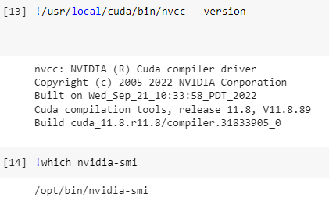

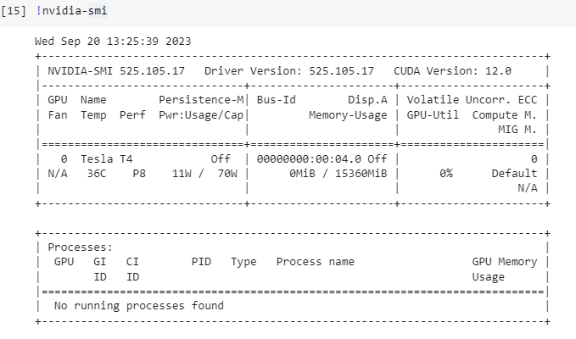

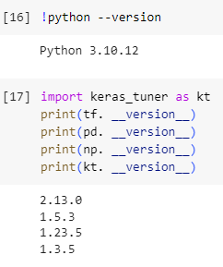

# Resultados 35 y 42 Algoritmo Hyperband

/usr/local/lib/python3.10/dist-packages/keras/src/engine/training.py:3000: UserWarning: You are saving your model as an HDF5 file via `model.save()`. This file format is considered legacy. We recommend using instead the native Keras format, e.g. `model.save('my_model.keras')`.

saving_api.save_model(

n_days 35 {'units': 288, 'lr': 0.0001687328693742953, 'dropout': 0.1, 'recurrent_dropout': 0.0, 'batch_size': 32, 'tuner/epochs': 50, 'tuner/initial_epoch': 0, 'tuner/bracket': 0, 'tuner/round': 0}

otro 35 <class '__main__.MyTuner'>

Results summary

Results in /content/drive/MyDrive/a Tesis de Grado/Tesis Versiones/tesis2023/modelos /salidasModelosHypertuner/hyperband/SMAPE-max_trials50- epochs100-aleatorio 35

Showing 1 best trials

Objective(name="val_loss", direction="min")

Trial 0085 summary

Hyperparameters:

units: 288

lr: 0.0001687328693742953

dropout: 0.1

recurrent_dropout: 0.0

batch_size: 32

tuner/epochs: 50

tuner/initial_epoch: 0

tuner/bracket: 0

tuner/round: 0

Score: 0.0804145559668541

results_summary <class 'NoneType'>

n_days 42 {'units': 288, 'lr': 0.0006199627420337139, 'dropout': 0.1, 'recurrent_dropout': 0.4, 'batch_size': 32, 'tuner/epochs': 50, 'tuner/initial_epoch': 17, 'tuner/bracket': 3, 'tuner/round': 3, 'tuner/trial_id': '0046'}

otro 42 <class '__main__.MyTuner'>

Results summary

Results in /content/drive/MyDrive/a Tesis de Grado/Tesis Versiones/tesis2023/modelos /salidasModelosHypertuner/hyperband/SMAPE-max_trials50- epochs100-aleatorio 42

Showing 1 best trials

Objective(name="val_loss", direction="min")

Trial 0050 summary

Hyperparameters:

units: 288

lr: 0.0006199627420337139

dropout: 0.1

recurrent_dropout: 0.4

batch_size: 32

tuner/epochs: 50

tuner/initial_epoch: 17

tuner/bracket: 3

tuner/round: 3

tuner/trial_id: 0046

Score: 0.08229460567235947

results_summary <class 'NoneType'>

WARNING:tensorflow:Detecting that an object or model or tf.train.Checkpoint is being deleted with unrestored values. See the following logs for the specific values in question. To silence these warnings, use `status.expect_partial()`. See <https://www.tensorflow.org/api_docs/python/tf/train/Checkpoint#restorefor> details about the status object returned by the restore function.

## Resumen resultados Algoritmo Hyperband

|  |  |  |
| --- | --- | --- |
| Score | N_days para atrás | El Mejor |
| 0.07861421257257462 | 28 | x |
| 0.0804145559668541 | 35 | - |
| 0.08229460567235947 | 42 | - |

Hasta ahora el mejor rendimiento es el de n_days=28, es decir, tomando los 28 dias anteriores para pronosticar los siguientes 7

## Siguientes pasos a realizar

Ejecutar el modelo de 28 días ejecutarlo en 1000 epochs (justificar la cantidad de epochs)

Comparar los resultados del modelo sobre los otros estudios de tráfico web

Armar el dataframe con los datos de google analytics 4

Ejecutar el modelo sobre el dataframe de google analytics 4

Validar los resultados si son parecidos a los obtenidos con universal analytics

1. **Planificación Temporal 2022**

|  |  |  |
| --- | --- | --- |
| **Actividad** | **Tiempo Estimado** | **Referencia** |
| Relevar y analizar distintos modelos de pronóstico de series de tiempo de tráfico web.   * Selección de los buscadores académicos * Generación de filtros de búsqueda * Aplicación de filtros de búsqueda y evaluación de resultados. | 1 mes | A |
| Tratamiento de los datos | 3 meses | B |
| Determinar la adecuación de cada uno de los modelos propuestos de la bibliografía a la problemática.   * Listar los modelos propuestos resultantes de la búsqueda bibliográfica. * Comparar los modelos. * Seleccionar los modelos que se adecuen a la problemática. | 1 mes | C |
| Definir indicadores para medir el desempeño de los modelos.   * Realizar una búsqueda bibliográfica de los indicadores para medir el desempeño. * Analizar y seleccionar los indicadores para medir el desempeño. | 1 mes | D |
| Generar los Modelos   * Generar la prueba de diseño. * Construir los modelos. | 1 meses | E |
| Realizar la evaluación del desempeño de los modelos.   * Evaluar y ajustar los modelos. | 1 mes | F |
| Validar los modelos. | 1 mes | G |
| Realizar la escritura del documento de tesis. | 11 meses | H |
| TOTAL | 11 meses | |

# Actualización 7-12-2022

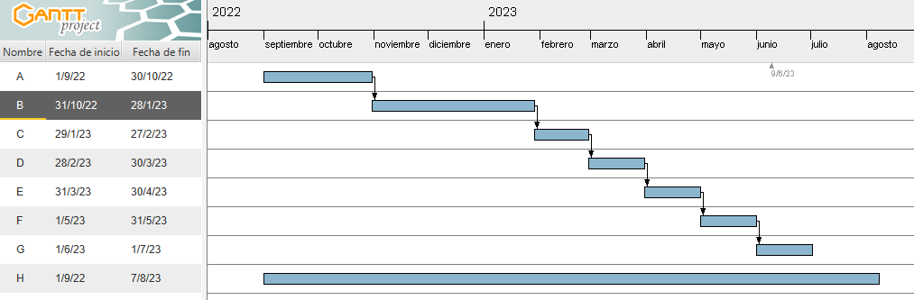

# Actualización 20-09-2023

